Streamlining Ticket Assignment for Efficient Support Operations

### Problem statement:

In many support organizations, ticket assignment is often handled manually or through rigid rules. This process leads to inefficiencies such as delayed response times, uneven workload distribution among agents, and lack of transparency in ticket ownership. As the volume of support requests increases, manual assignment becomes error-prone, resulting in lower customer satisfaction and higher operational costs.

There is a need for a streamlined, intelligent ticket assignment system that can automatically categorize, prioritize, and route tickets to the most suitable agents based on factors such as expertise, availability, workload, and service-level agreements (SLAs). Such a system should reduce manual intervention, optimize resource utilization, and enhance the overall efficiency of support operations while ensuring timely resolution for customers.

**SKILLS:**

* Portal login & navigation
* User, group, and role handling
* Ticket management
* Workflow design

### OBJECTIVE:

The objective is to automate ticket assignment in order to minimize manual effort and ensure a fair distribution of workload among support agents. By intelligently matching tickets with agents based on their expertise and availability, the process will help reduce response and resolution times for customer issues. This approach aims to improve transparency and accountability in ticket ownership, while enhancing overall customer satisfaction and operational efficiency.

### TASK INITIATION:

**Milestone 1:** Users

**Activity 1:** Create Users

1. Open service now.
2. Click on All >> search for users
3. Select Users under system security
4. Fill the following details to create a new user

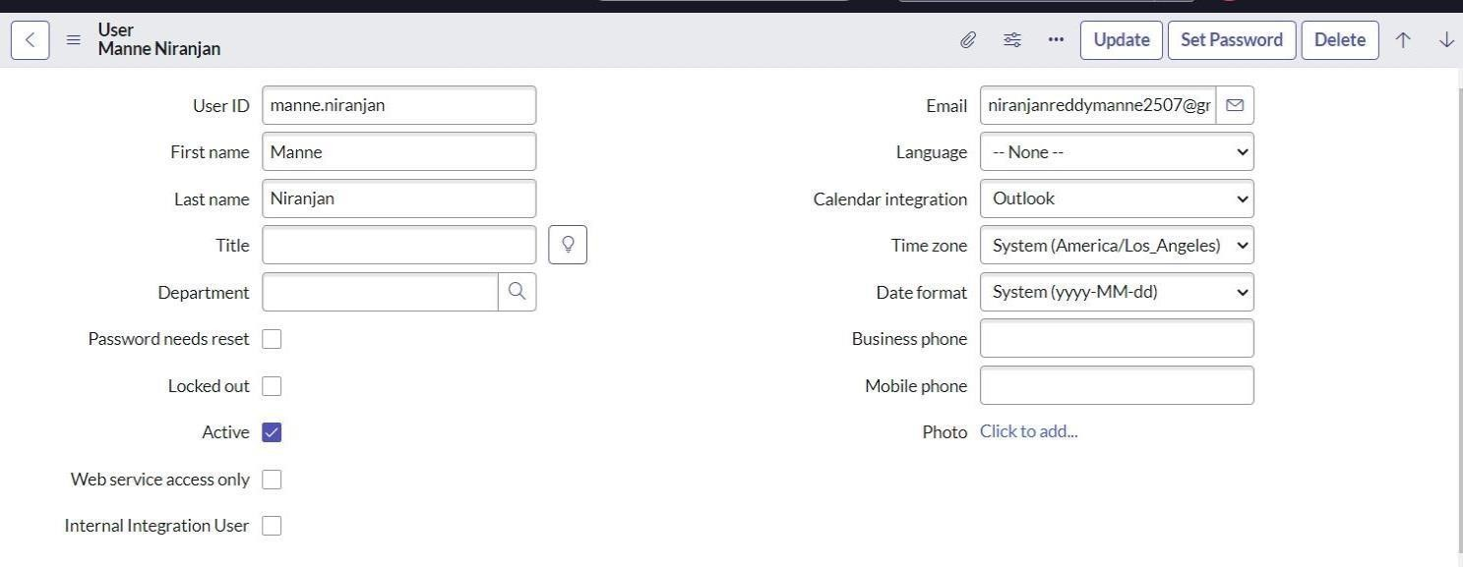

1. Click on submit
2. Create one more use
3. Create another user with the following details

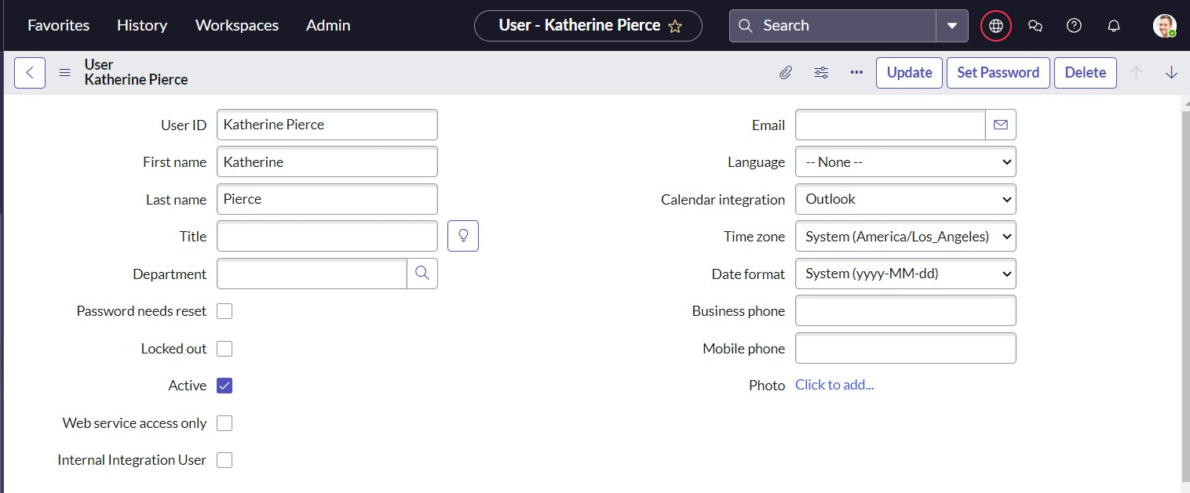

1. Click on submit

# Milestone 2: Groups

**Activity 1: Create Groups**

1. Open service now.
2. Click on All >> search for groups
3. Select groups under system security
4. Click on new
5. Fill the following details to create a new group

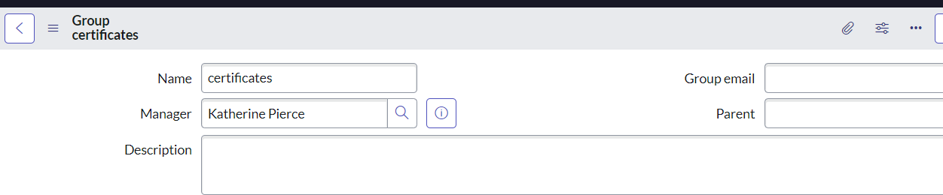

1. Click on submit

Create one more group:

1. 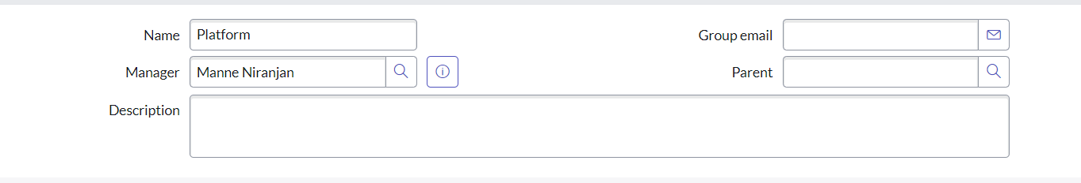Create another group with the following details
2. Click on submit

# Milestone 3: Roles

**Activity 1: Create Roles**

1. Open service now.
2. Click on All >> search for roles
3. Select roles under system security
4. Click on new
5. Fill the following details to create a new role

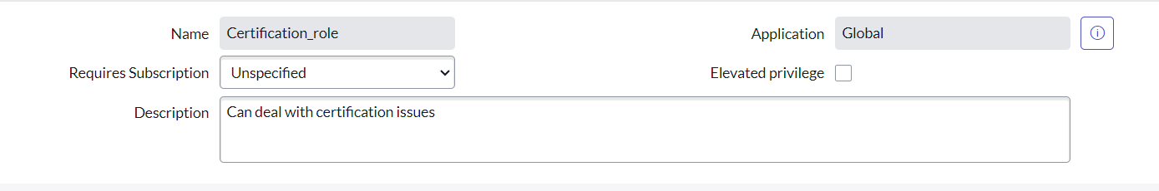

1. Click on submit

Create one more role:

1. Create another role with the following details

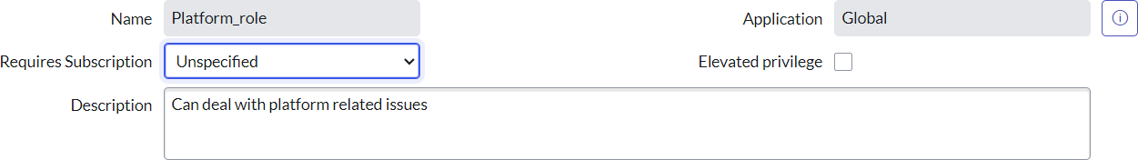

1. Click on submit

# Milestone 4: Tables

**Activity 1: Create Tables**

1. Open service now.
2. Click on All >> search for tables
3. Select tables under system definition
4. Click on new
5. Fill the following details to create a new table Label : Operations related

Check the boxes Create module & Create mobile module

1. Under new menu name : Operations related
2. Under table columns give the columns

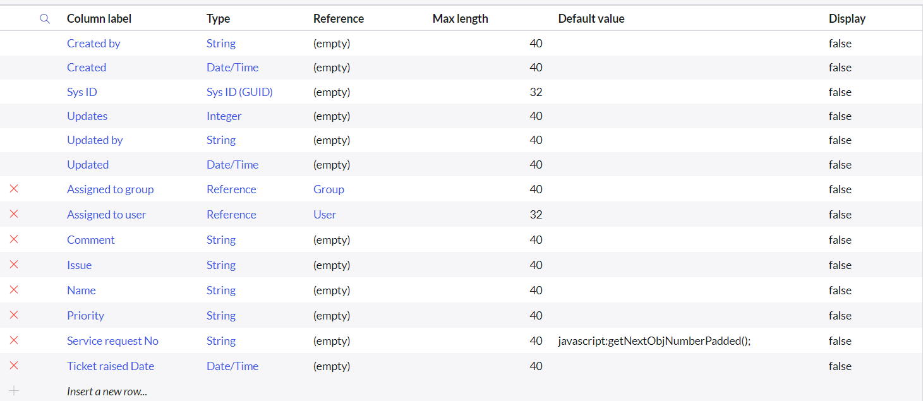

1. Click on submit

Create choices for the issue filed by using form design Choices are

* 1. unable to login to platform
  2. 404 error
  3. regarding certificates
  4. regarding user expired

# Milestone 5: Assign roles s User to groups

**Activity 1:** Assign roles & users to certificate group

1. Open service now.
2. Click on All >> search for tables
3. Select tables under system definition
4. Select the certificates group
5. Under group members
6. Click on edit
7. Select Katherine Pierce and save
8. Click on roles
9. Select Certification_role and save

**Activity 2:** Assign roles & users to platform group

1. Open service now.
2. Click on All >> search for tables
3. Select tables under system definition
4. Select the platform group
5. Under group members
6. Click on edit
7. Select Manne Niranjan and save
8. Click on roles
9. Select Platform_role and save

**Milestone 6: Assign roles to tables Activity 1:** Assign roles to tables

1. Open service now.
2. Click on All >> search for tables
3. Select operations related table
4. Click on the Application Access
5. Click on u_operations_related read operation
6. Click on the profile on top right side
7. Click on elevate role
8. Click on security admin and click on update
9. Under Requires role
10. Double click on insert a new row
11. Give platform role
12. And add certificate role
13. Click on update

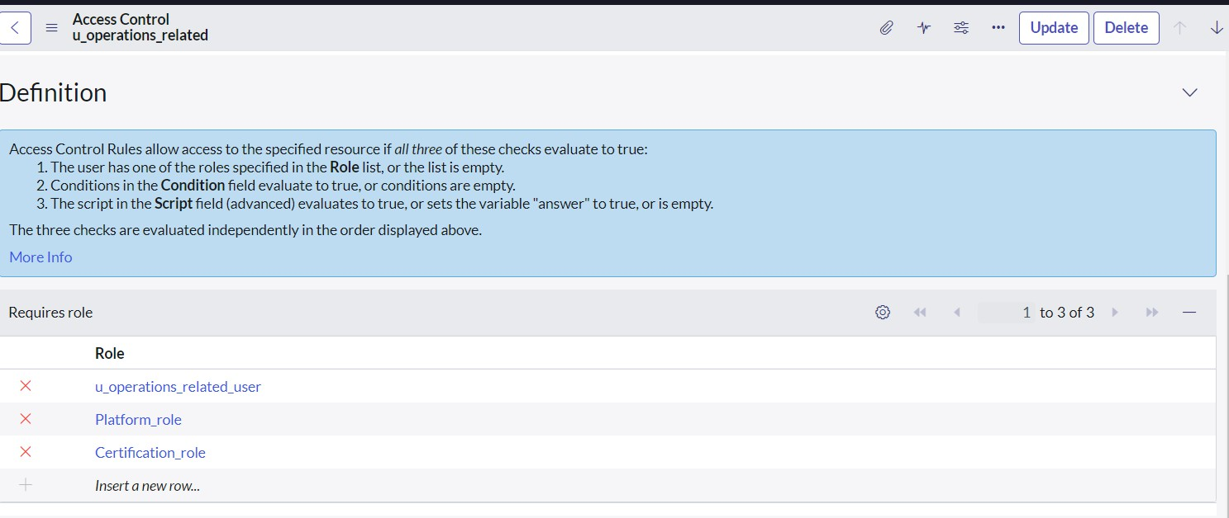

1. Click on u_operations_related write operation
2. Under Requires role
3. Double click on insert a new row
4. Give platform role
5. And add certificate role

# Milestone 7: Create ACL Activity 1: Create ACL

1. Open service now.
2. Click on All >> search for ACL
3. Select Access Control(ACL) under system security
4. Click on new
5. 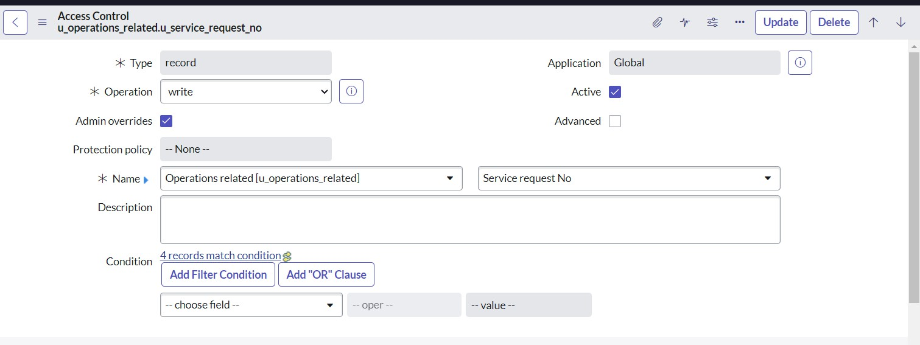Fill the following details to create a new ACL
6. Scroll down under requires role
7. Double click on insert a new row
8. Give admin role
9. Click on submit
10. 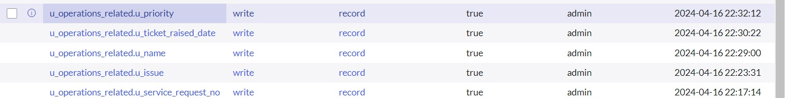Similarly create 4 acl for the following fields

# Milestone 8: Flow

## **Activity 1:** Create a Flow to Assign operations ticket to group

1. Open service now.
2. Click on All >> search for Flow Designer
3. Click on Flow Designer under Process Automation.
4. After opening Flow Designer Click on new and select Flow.
5. Under Flow properties Give Flow Name as “ Regarding Certificate”.
6. Application should be Global.
7. Select Run user as “ System user ” from that choice.
8. Click on Submit.

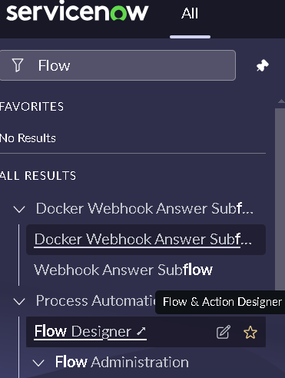

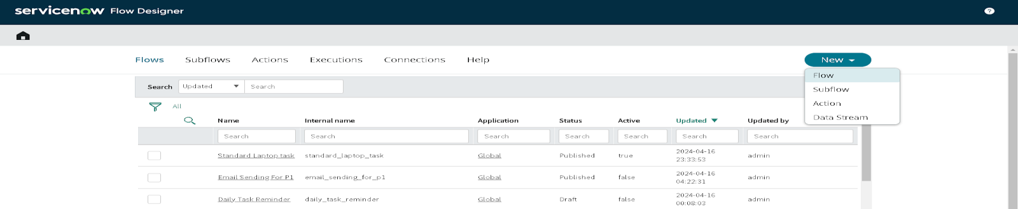

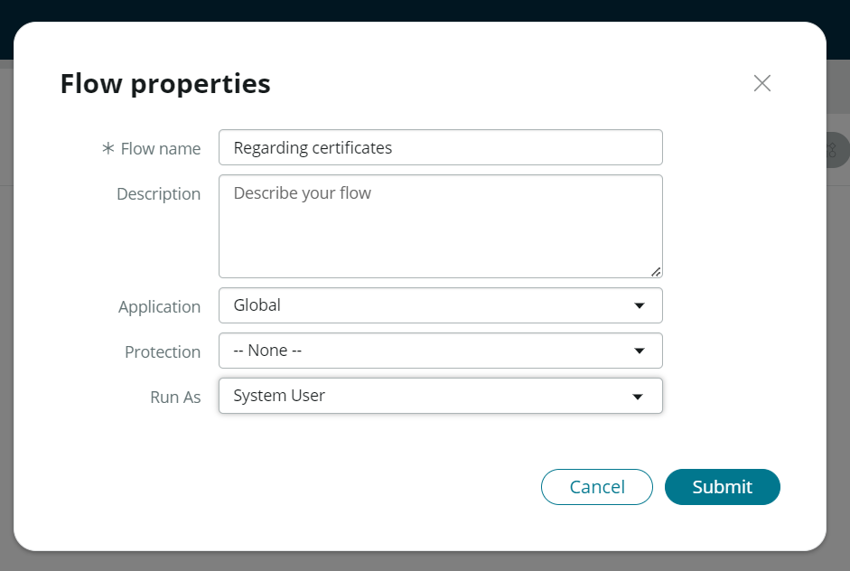

1. Click on Add a trigger
2. Select the trigger in that Search for “create or update a record” and select that.
3. Give the table name as “ Operations related ”.
4. Give the Condition as Field : issue

Operator : is

Value : Regrading Certificates

1. After that click on Done.

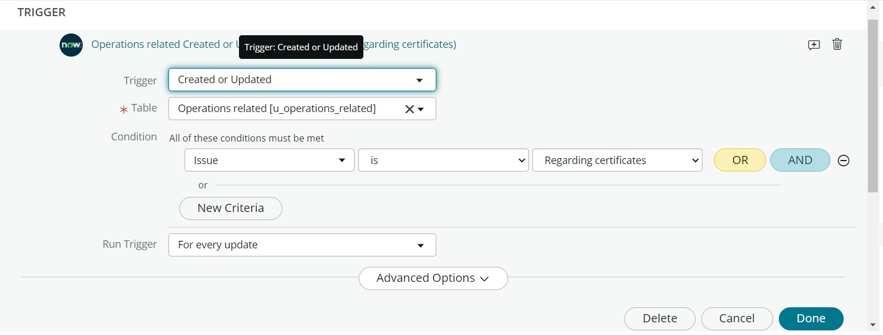

1. Now under Actions.
2. Click on Add an action.
3. Select action in that search for “ Update Record ”.
4. In Record field drag the fields from the data navigation from left side
5. Table will be auto assigned after that
6. Give the field as “ Assigned to group ”
7. Give value as “ Certificates ”
8. Click on Done.
9. Click on Save to save the Flow.
10. Click on Activate.

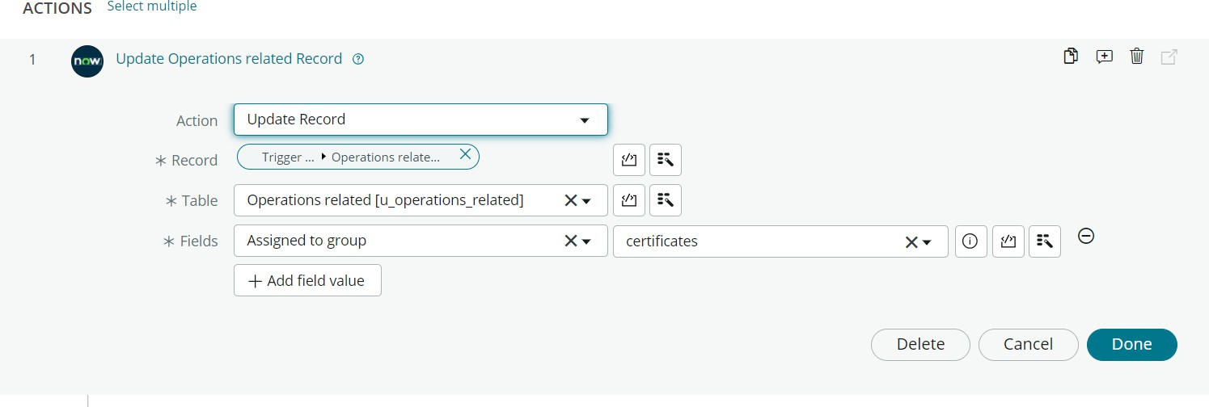

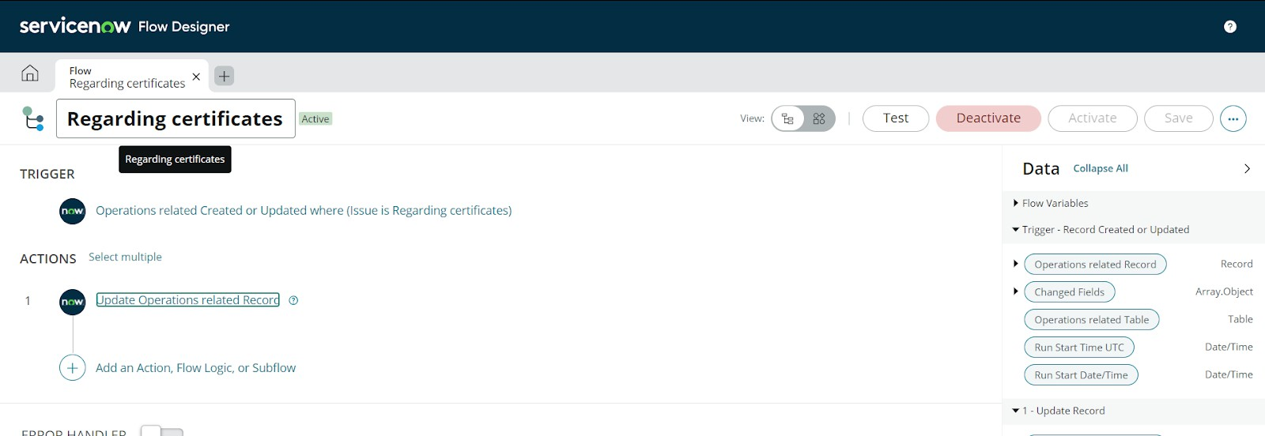

**Activity 2:** Create a Flow to Assign operations ticket to Platform group

1. Open service now.
2. Click on All >> search for Flow Designer
3. Click on Flow Designer under Process Automation.
4. After opening Flow Designer Click on new and select Flow.
5. Under Flow properties Give Flow Name as “ Regarding Platform ”.
6. Application should be Global.
7. Select Run user as “ System user ” from that choice.
8. Click on Submit.
9. Click on Add a trigger
10. Select the trigger in that Search for “create or update a record” and select that.
11. Give the table name as “ Operations related ”.
12. Give the Condition as Field : issue

Operator : is

Value : Unable to login to platform

1. Click on New Criteria Field : issue

Operator : is Value : 404 Error

1. Click on New Criteria Field : issue

Operator : is

Value : Regrading User expired

1. After that click on Done.
2. Now under Actions.
3. Click on Add an action.
4. Select action in that search for “ Update Record ”.
5. In Record field drag the fields from the data navigation from left side
6. Table will be auto assigned after that
7. Give the field as “ Assigned to group ”.
8. Give value as “ Platform ”.
9. Click on Done.
10. Click on Save to save the Flow.
11. Click on Activate.

## Conclusion

The implementation of the automated ticket routing system at ABC Corporation has been a significant success. By leveraging the capabilities of ServiceNow, we have streamlined the process of assigning support tickets to the appropriate teams, addressing the challenges of manual routing, and ensuring timely resolution of issues.